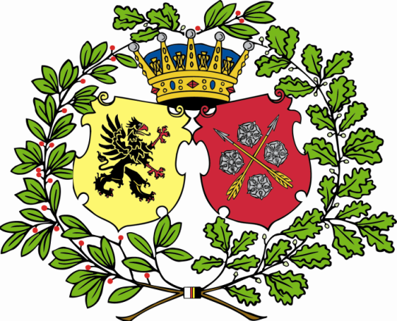

1 post for the spring semester 2017 is announced as

**Assisting international secretary**

As assisting international secretary you will assist the international secretaries in welcoming the nation's international students. You have the main responsibility for the activities in the beginning of the semester during welcome week and for the activities aimed at international students that are not covered by the recce package. There will be plenty of space for your own ideas and new, creative suggestions of activities are welcomed. Applications must be received by the first curator before  
December 15th, 23:59 through 1q@snerikes.se

The election of assistant international secretary takes place on the nation’s board meeting December 21st. Applicants must be members of the nation. This post makes you an official at the nation.

Theodor Söderberg

*Förste kurator*